Autolamp Delay Control Function – CGEA1.3

Functional Description

The Autolamps feature provides automatic control of the headlamps and position/parklamps. The lamps which makeup the headlamps consist of the Low Beams and High Beams. The Autolamps feature is enabled and disabled by the customer from the Autolamp switch or Autolamp position on the Headlamps switch. Using the Message Center Switches and Display, the customer can change the length of delay before the Autolamps turn off after a key transition to OFF.

Starting in MY2019 with U625/U611 the Settings are migrating from the cluster to Center stack. This STSS supports displaying settings in the cluster or configuring the cluster settings off if they are displayed in the Center stack.

Autolamp Delay Control Function is displayed only in the Message Center while it is in the appropriate SETUP display. See Message Center X Display_Y Button Interface Section, where X and Y are appropriate values in this document for details on when this display is active.

Interfaces

Interface Context Diagram (I/O Block Diagram)

Figure 1 Autolamp Delay Function Context Diagram

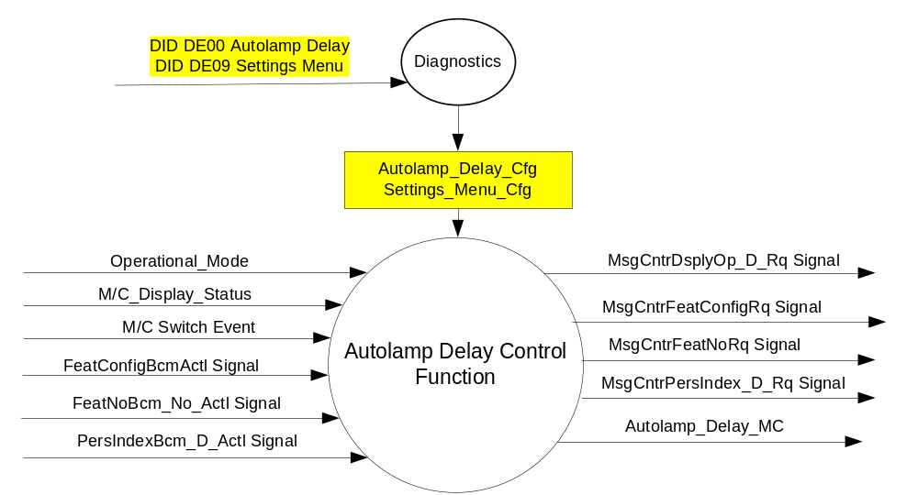

Inputs

- INTERNAL:
- Operational_Mode
- Autolamp_Delay_Cfg
- Settings_Menu_Cfg
- M/C Switch Event
- M/C_Display_Status
- MUX signals on the CAN Bus

- FeatConfigBcmActl Signal
Signal Name | Size (bits) | Detail | Units | Res. | Offset | State Encoded | Min | Max
FeatConfigBcmActl | 16 | - | Undefined | 1 | 0 |  | 0  (0x0) | 65535  (0xFFFF)

- FeatNoBcm_No_Actl Signal
Signal Name | Size (bits) | Detail | Units | Res. | Offset | State Encoded | Min | Max
FeatNoBcm_No_Actl | 16 | - | Number | 1 | 0 |  | 0  (0x0) | 65535  (0xFFFF)

- PersIndexBcm_D_Actll Signal
Signal Name | Size (bits) | Detail | Units | Res. | Offset | State Encoded | Min | Max
PersIndexBcm_D_Actl | 3 |  | SED | 1 | 0 |  | 0  (0x0) | 1  (0x7)
 |  | PERS_1 |  |  |  | 0 (0x0)
 |  | PERS_2 |  |  |  | 1 (0x1)
 |  | PERS_3 |  |  |  | 2 (0x2)
 |  | PERS_4 |  |  |  | 3 (0x3)
 |  | Vehicle |  |  |  | 4 (0x4)
 |  | Unused |  |  |  | 5(0x5)
 |  | Unused |  |  |  | 6 (0x6)
 |  | Unused |  |  |  | 7 (0x7)

Outputs
- Autolamp_Delay_MC
- MUX signals on the CAN Bus

- MsgCntrDsplyOp_D_Rq Signal
Signal Name | Size (bits) | Detail | Units | Res. | Offset | State Encoded | Min | Max
MsgCntrDsplyOp_D_Rq | 3 |  | SED | 1 | 0 |  | 0  (0x0) | 1  (0x7)
 |  | NULL |  |  |  | 0 (0x0)
 |  | QUERY |  |  |  | 1 (0x1)
 |  | SET |  |  |  | 2 (0x2)
 |  | UPLOAD |  |  |  | 3 (0x3)
 |  | RESTORE |  |  |  | 4 (0x4)
 |  | COPY |  |  |  | 5(0x5)
 |  | Not used |  |  |  | 6 (0x6)
 |  | Not Used |  |  |  | 7 (0x7)
.
- MsgCntrFeatConfigRq Signal
Signal Name | Size (bits) | Detail | Units | Res. | Offset | State Encoded | Min | Max
MsgCntrFeatConfigRq | 16 |  | Undefined | 1 | 0 |  | 0  (0x0) | 65535  (0xFFFF)

- MsgCntrFeatNoRq Signal
Signal Name | Size (bits) | Detail | Units | Res. | Offset | State Encoded | Min | Max
MsgCntrFeatNoRq | 16 |  | Number | 1 | 0 |  | 0  (0x0) | 65535  (0xFFFF)

- MsgCntrPersIndex_D_Rq
Signal Name | Size (bits) | Detail | Units | Res. | Offset | State Encoded | Min | Max
MsgCntrPersIndex_D_Rq | 3 |  | SED | 1 | 0 |  | 0  (0x0) | 1  (0x7)
 |  | PERS_1 |  |  |  | 0 (0x0)
 |  | PERS_2 |  |  |  | 1 (0x1)
 |  | PERS_3 |  |  |  | 2 (0x2)
 |  | PERS_4 |  |  |  | 3 (0x3)
 |  | Vehicle |  |  |  | 4 (0x4)
 |  | Not Used |  |  |  | 5(0x5)
 |  | Not Used |  |  |  | 6 (0x6)
 |  | Not Used |  |  |  | 7 (0x7)
.

Function/Performance

Operational Modes

Mode | Differentiating Vehicle Conditions
Sleep Mode | Autolamp Delay Text Message Disabled
Limited Mode | Autolamp Delay Text Message Disabled
Normal Mode | Autolamp Delay Text Message Enabled / Disabled
Crank Mode | Autolamp Delay Text Message Enabled / Disabled

Voltage Levels

Refer to the Cluster Features table located in the Operational Modes and Voltage Range Strategies Section in this SPSS.

Human-Machine Interface

Visual

Indicator Graphics / Display Format
For High End Display (SHMI), refer to “<Program> Cluster Menu Structure.xls” and Program VAPS Model.
STANDARD MENU
Menu level 3 |  | Menu level 4
T: Vehicle S: 3:6
Autolamp Delay |  | T: Autolamp Delay S: 4:4
Autolamp Delay |  | Off
Autolamp Delay |  | 10 seconds
Autolamp Delay | ☑ | 20 seconds (Default Setting)
Autolamp Delay |  | 30 seconds
Autolamp Delay |  | 60 seconds
Autolamp Delay |  | 90 seconds
Autolamp Delay |  | 120 seconds
Autolamp Delay |  | 180 seconds

SIMPLIFIED MENU
Menu level 3 |  | Menu level 4
T: Vehicle
Autolamp Delay |  | T: Autolamp
Autolamp Delay |  | Off
Autolamp Delay |  | 10 seconds
Autolamp Delay | ☑ | 20 seconds (Default Setting)
Autolamp Delay |  | 120 seconds

For "B" display, refer to Message Center Function description reference "Text Message List - BEF Displays 2x14.xls" file -- Message ID SU 170, 180, 190

Indicator Color Coordinates

Reference section COLOR & ILLUMINATION REQUIREMENTS (GRAPHICS)

Indicator Characteristics

Refer to Message Center X Display_Y Button Interface Section, where X and Y are appropriate values in this document.

Audio

None

Switch Control Logic

Consumer access to the Autolamp Control Configuration shall be as specified in the message center basic functionality display as specified in Message Center X Display_Y Button Interface Section, where X and Y are appropriate values in this document.

System Accuracy

Within a 100msec of receiving a message that results in a change of state the cluster will update the display to the proper status.

Operation: Performance and Functional

Subsystem Algorithm Flowchart / State Diagram

Figure 2: Autolamp Delay Diagnostic Configuration Flowcharts

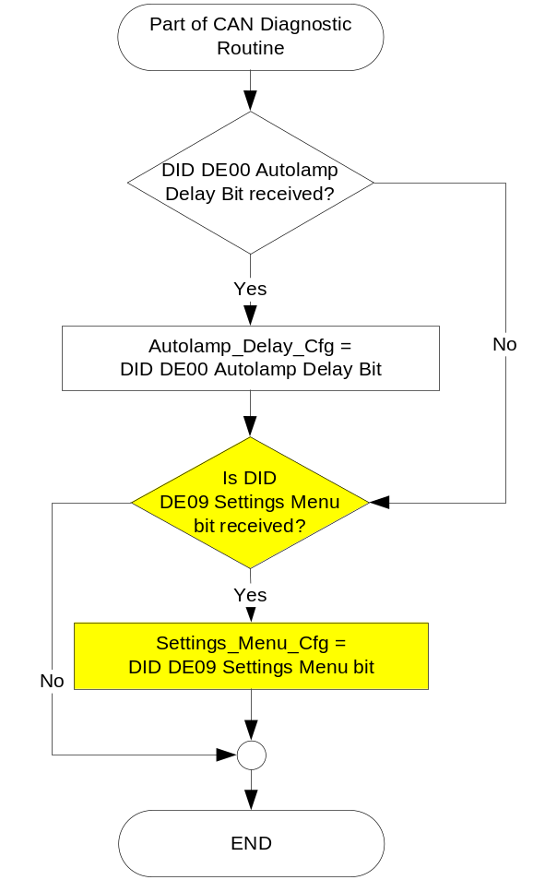

Figure 3: Autolamp Delay input request Flowcharts

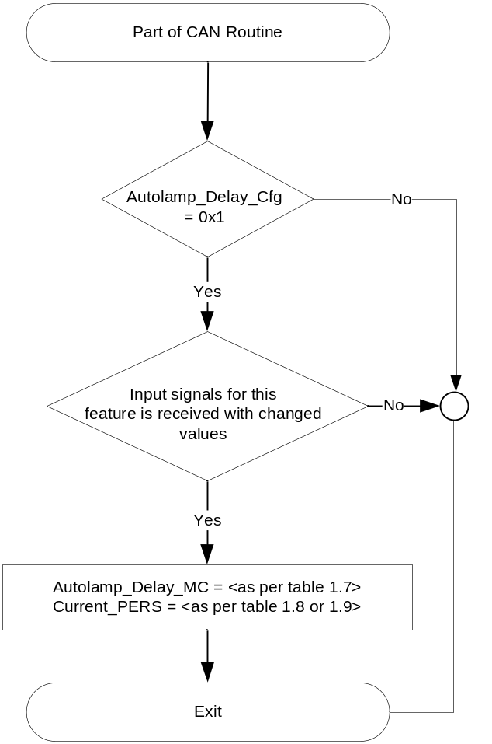

Figure 4: Autolamp Delay output SET request Flowcharts

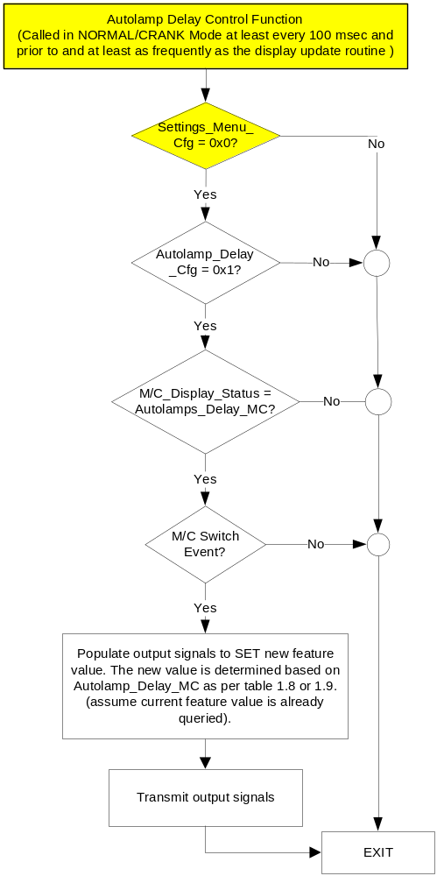

NOTE: In the Autolamp Delay Function Flowchart, the definition of "M/C Switch Event" is defined in Message Center X Display_Y Button Interface Section, where X and Y are appropriate values in this document.

Operation Description (supports algorithm flowchart /state diagram)

- Autolamp_Delay_MC State Assignment

Use for B-Display and SHI-Display – Standard Memu
FeatNoBcm_No_Actl | FeatConfigBcmActl | PersIndexBcm_D_Actl | Autolamp_Delay_MC | Current_PERS ⁽³⁾
0x040D ⁽¹⁾ | 0x0000 – 0x0009 | 0x0 – 0x4 | 0x0 (OFF) | 0x0 – 0x4
0x040D ⁽¹⁾ | 0x000A – 0x0013 | 0x0 – 0x4 | 0x1 (10 secs) | 0x0 – 0x4
0x040D ⁽¹⁾ | 0x0014 – 0x001D | 0x0 – 0x4 | 0x2 (20 secs) | 0x0 – 0x4
0x040D ⁽¹⁾ | 0x001E – 0x003B | 0x0 – 0x4 | 0x3 (30 secs) | 0x0 – 0x4
0x040D ⁽¹⁾ | 0x003C – 0x0059 | 0x0 – 0x4 | 0x4 (60 secs) | 0x0 – 0x4
0x040D ⁽¹⁾ | 0x005A – 0x0077 | 0x0 – 0x4 | 0x5 (90 secs) | 0x0 – 0x4
0x040D ⁽¹⁾ | 0x0078 – 0x00B3 | 0x0 – 0x4 | 0x6 (120 secs) | 0x0 – 0x4
0x040D ⁽¹⁾ | 0x00B4 – 0x00FF | 0x0 – 0x4 | 0x7 (180 secs) | 0x0 – 0x4
0x040D ⁽¹⁾ | Other ⁽²⁾ |  | 0x8 (Error) | Last known
Missing per Section 1.4.1 ⁽²⁾ |  |  | 0x8 (Error) | Last Known
⁽¹⁾ Autolamp Delay Feature Number. Reference is Feat Num table in “Vehicle Personalization FS”
⁽²⁾ Message Response is Faulted
⁽³⁾ Equal to the received “PersIndex<--->” signal value . When faulted Keep last known value.

Use for SHI-Display – Simplified Memu
FeatNoBcm_No_Actl | FeatConfigBcmActl | PersIndexBcm_D_Actl | Autolamp_Delay_MC | Current_PERS ⁽³⁾
0x040D ⁽¹⁾ | 0x0000 – 0x0009 | 0x0 – 0x4 | 0x0 (OFF) | 0x0 – 0x4
0x040D ⁽¹⁾ | 0x000A – 0x0013 | 0x0 – 0x4 | 0x1 (10 secs) | 0x0 – 0x4
0x040D ⁽¹⁾ | 0x0014 – 0x001D | 0x0 – 0x4 | 0x2 (20 secs) | 0x0 – 0x4
0x040D ⁽¹⁾ | 0x001E – 0x00FF | 0x0 – 0x4 | 0x6 (120 secs) | 0x0 – 0x4
0x040D ⁽¹⁾ | Other ⁽²⁾ |  | 0x8 (Error) | Last known
Missing per Section 1.4.1 ⁽²⁾ |  |  | 0x8 (Error) | Last Known
⁽¹⁾ Autolamp Delay Feature Number. Reference is Feat Num table in “Vehicle Personalization FS”
⁽²⁾ Message Response is Faulted
⁽³⁾ Equal to the received “PersIndex<--->” signal value . When faulted Keep last known value.

- B-Display MC Display and Next ALD Stat State based upon Autolamp_Delay_MC
Autolamp  _Delay  _MC | Message Center Display  Message ID: SU170,180,190 | Reset Switch Event | MsgCntrDsplyOp_D_Rq  Signal | MsgCntrFeatNoRq  Signal | MsgCntrFeatConfigRq  Signal | MsgCntrPersIndex_D_Rq  Signal
0x0  (OFF) | AUTOLAMP (SEC)  <0> 10 20 | Yes | SET (0x2) | 0x040D | 10 (0x000A) | Current_PERS
0x1  (10 secs) | AUTOLAMP (SEC)  0 <10> 20 | Yes | SET (0x2) | 0x040D | 20 (0x0014) | Current_PERS
0x2  (20 secs) | AUTOLAMP (SEC)  0 10 <20> | Yes | SET (0x2) | 0x040D | 30 (0x001E) | Current_PERS
0x3  (30 secs) | AUTOLAMP (SEC)  <30> 60 90 | Yes | SET (0x2) | 0x040D | 60 (0x003C) | Current_PERS
0x4  (60 secs) | AUTOLAMP (SEC)  30 <60> 90 | Yes | SET (0x2) | 0x040D | 90 (0x005A) | Current_PERS
0x5  (90 secs) | AUTOLAMP (SEC)  30 60 <90> | Yes | SET (0x2) | 0x040D | 120 (0x0078) | Current_PERS
0x6  (120 secs) | AUTOLAMP (SEC)  <120> 180 | Yes | SET (0x2) | 0x040D | 180 (0x00B4) | Current_PERS
0x7  (180 secs) | AUTOLAMP (SEC)  120 <180> | Yes | SET (0x2) | 0x040D | 0 (0x0000) | Current_PERS
0x8  (Error) | AUTOLAMP (SEC)  0 10 20 | Yes | SET (0x2) | 0x040D | 20 (0x0014) | Current_PERS

- SHMI Display and MC Autolamp_Delay Request Messages

based upon Autolamp_Delay_MC

Use for SHI-Display Standard Menu
Autolamp  _Delay  _MC | Display Menu | 5-Button Switch Selection Event | MsgCntrDsplyOp_D_Rq  Signal | MsgCntrFeatNoRq  Signal | MsgCntrFeatConfigRq  Signal | MsgCntrPersIndex_D_Rq  Signal
0x0  (OFF) | 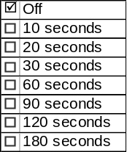 | Up/Down + OK  (Select 10, 20, 30, 60, 90, 120, 180) | SET (0x2) | 0x040D | 0x000A (If 10 is selected)  0x0014 (If 20 is selected)  0x001E (If 30 is selected)  0x003C (If 60 is selected)  0x005A (If 90 is selected)  0x0078 (If 120 is selected)  0x00B4 (If 180 is selected) | Current_PERS
0x1  (10 secs) | 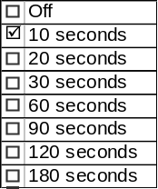 | Up/Down + OK  (Select Off, 20, 30, 60, 90, 120, 180) | SET (0x2) | 0x040D | 0x0000 (If Off is selected)  0x0014 (If 20 is selected)  0x001E (If 30 is selected)  0x003C (If 60 is selected)  0x005A (If 90 is selected)  0x0078 (If 120 is selected)  0x00B4 (If 180 is selected) | Current_PERS
0x2  (20 secs) | 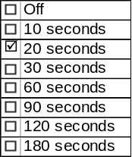 | Up/Down + OK  (Select Off, 10, 30, 60, 90, 120, 180) | SET (0x2) | 0x040D | 0x0000 (If Off is selected)  0x000A (If 10 is selected)  0x001E (If 30 is selected)  0x003C (If 60 is selected)  0x005A (If 90 is selected)  0x0078 (If 120 is selected)  0x00B4 (If 180 is selected) | Current_PERS
0x3  (30 secs) | 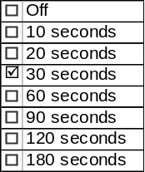 | Up/Down + OK  (Select Off, 10, 20, 60, 90, 120, 180) | SET (0x2) | 0x040D | 0x0000 (If Off is selected)  0x000A (If 10 is selected)  0x0014 (If 20 is selected)  0x003C (If 60 is selected)  0x005A (If 90 is selected)  0x0078 (If 120 is selected)  0x00B4 (If 180 is selected) | Current_PERS
0x4  (60 secs) | 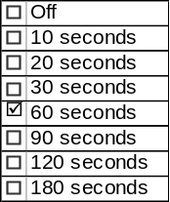 | Up/Down + OK  (Select Off, 10, 20, 30, 90, 120, 180) | SET (0x2) | 0x040D | 0x0000 (If Off is selected)  0x000A (If 10 is selected)  0x0014 (If 20 is selected)  0x001E (If 30 is selected)  0x005A (If 90 is selected)  0x0078 (If 120 is selected)  0x00B4 (If 180 is selected) | Current_PERS
0x5  (90 secs) | 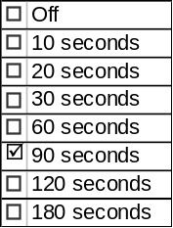 | Up/Down + OK  (Select Off, 10, 20, 30, 60, 120, 180) | SET (0x2) | 0x040D | 0x0000 (If Off is selected)  0x000A (If 10 is selected)  0x0014 (If 20 is selected)  0x001E (If 30 is selected)  0x003C (If 60 is selected)  0x0078 (If 120 is selected)  0x00B4 (If 180 is selected) | Current_PERS
0x6  (120 secs) | 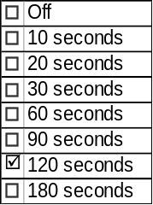 | Up/Down + OK  (Select Off, 10, 20, 30, 60, 90, 180) | SET (0x2) | 0x040D | 0x0000 (If Off is selected)  0x000A (If 10 is selected)  0x0014 (If 20 is selected)  0x001E (If 30 is selected)  0x003C (If 60 is selected)  0x005A (If 90 is selected)  0x00B4 (If 180 is selected) | Current_PERS
0x7  (180 secs) | 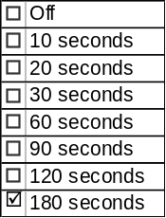 | Up/Down + OK  (Select Off, 10, 20, 30, 60, 90, 120) | SET (0x2) | 0x040D | 0x0000 (If Off is selected)  0x000A (If 10 is selected)  0x0014 (If 20 is selected)  0x001E (If 30 is selected)  0x003C (If 60 is selected)  0x005A (If 90 is selected)  0x0078 (If 120 is selected) | Current_PERS
0x8  (Error) | 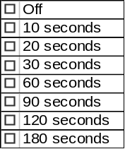 | Up/Down + OK  (Select Any) | SET (0x2) | 0x040D | 0x0000 (If Off is selected)  0x000A (If 10 is selected)  0x0014 (If 20 is selected)  0x001E (If 30 is selected)  0x003C (If 60 is selected)  0x005A (If 90 is selected)  0x0078 (If 120 is selected)  0x00B4 (If 180 is selected) | Current_PERS

Use for SHI-Display Standard Menu
Autolamp  _Delay  _MC | Display Menu | 5-Button Switch Selection Event | MsgCntrDsplyOp_D_Rq  Signal | MsgCntrFeatNoRq  Signal | MsgCntrFeatConfigRq  Signal | MsgCntrPersIndex_D_Rq  Signal
0x0  (OFF) | 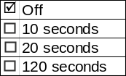 | Up/Down + OK  (Select 10, 20, 120 | SET (0x2) | 0x040D | 0x000A (If 10 is selected)  0x0014 (If 20 is selected)  0x0078 (If 120 is selected) | Current_PERS
0x1  (10 secs) | 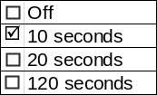 | Up/Down + OK  (Select Off, 20, 120) | SET (0x2) | 0x040D | 0x0000 (If Off is selected)  0x0014 (If 20 is selected)  0x0078 (If 120 is selected) | Current_PERS
0x2  (20 secs) | 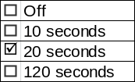 | Up/Down + OK  (Select Off, 10, 120) | SET (0x2) | 0x040D | 0x0000 (If Off is selected)  0x000A (If 10 is selected)  0x0078 (If 120 is selected) | Current_PERS
0x6  (120 secs) | 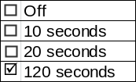 | Up/Down + OK  (Select Off, 10, 20) | SET (0x2) | 0x040D | 0x0000 (If Off is selected)  0x000A (If 10 is selected)  0x0014 (If 20 is selected) | Current_PERS
0x8  (Error) | 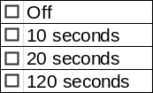 | Up/Down + OK  (Select Any) | SET (0x2) | 0x040D | 0x0000 (If Off is selected)  0x000A (If 10 is selected)  0x0014 (If 20 is selected)  0x0078 (If 120 is selected) | Current_PERS

- This feature will be set to ENABLED at the instrument cluster manufacturing plant. It will be set via diagnostic at Vehicle Operations using DID DE00. Autolamp_Delay_Cfg is set equal to the last value received in the diagnostic routine.
- The customer will have the ability to change the Autolamp Delay time of the auto lamp ON time when the Instrument Cluster Message Center (IC) is enabled (Operational Mode is Normal).
- There are 8 distinct and separate set points or values for auto lamp delay exit time in seconds. The BCM will retain this Autolamp Exit delay time as a one-byte value.
- The following are the predefined set points or Autolamp exit delay time values 0, 10, 20, 30, 60, 90, 120, 180 seconds (i.e. 0 to 3 minutes). In Simplified Menu, this has been reduced to 0, 10, 20 and 120 seconds.
- Note: The BCM default for Autolamp Delay time is 20 seconds.

Function Safety Classification (EMC)

Class B

Memory Storage

- Function Parameters
Parameter Name | Description | Value at  Battery Connect | Value at  Module Wake-up
Autolamp_Delay_MC | Output displayed in the M/C | Inactive | Do Not Init
MsgCntrDsplyOp_D_Rq Signal | Output Signal to indicate Request Type. | NULL (0x0) | Do Not Init
MsgCntrFeatNoRq Signal | Output Signal to indicate Feature Number. | (0x0000) | Do Not Init
MsgCntrFeatConfigRq Signal | Output Signal to Specify the desired feature Value. | (0x0000) | Do Not Init
MsgCntrPersIndex_D_Rq Signal | Output Signal to indicate which personality profile is being accessed. | Vehicle (0x4) | Do Not Init
FeatNoBcm_No_Actl Signal | Input signal sent from BCM to indicate Feature Number. | (0x0000) | Do Not Init
FeatConfigBcmActl Signal | Input signal sent from BCM to indicate current value of the feature setting for the feature that is being set or queried. | (0x0000) | Do Not Init
PersIndexBcm_D_Actl Signal | Input signal sent from BCM to indicate which personality profile is being reported. | Vehicle (0x4) | Do Not Init
Autolamp_Delay_Cfg | State indicator for feature presence controlled via CAN at EOL at VO plant. Set to enabled at Cluster Supplier Manufacturing Plant | Use Stored Value | Use Stored Value
Settings_Menu_Cfg | Configures cluster to display items in the Settings menu (Set to “cluster” at cluster supplier manufacturer plant) | Use Stored Value | Use Stored Value
M/C_Display_Status | State Indicator to identify which text is currently being displayed on Message Center display. See * | See * | See*
M/C Switch Event | Event that is indicated as per the switch interface for the Message Center. See * | See * | See*
Operational_Mode | 4 state indicator for cluster operational mode | Limited | Limited, Normal or Crank
* Refer to Message Center X Display_Y Button Interface Section, where X and Y are appropriate values in this document.

Reconfigurable Telltale

Not Applicable

Prove Out

Not applicable

Message Center Msg

Refer to Message Center Function description reference "Text Message List - BEF Displays 2x14.xls" file -- Message ID SU 170, 180, 190.

Message IDs for SHMI displays to be determined.

Error Handling

Missing Message Strategy

The signals will be declared missing as per the Diagnostics section of this SPSS.

DTCs states and history will be determined as per the Diagnostics section of this SPSS.

If Autolamp_Delay_Cfg = Disabled, the cluster shall never log a missing message DTC due to this feature.

Diagnostics

Self Test

None

Engineering Test Mode

Reference section “Dealer / Engineering Test Mode (ETM)”

Part II Performance

Supported Diagnostic Trouble Codes (DTCs)
DTC | Description
C14000 | Lost of Communication with CGEA_HS_BCM

DID DExx:
Block  Num | Block Description | Byte(s) | Bits | State: Description | "0" | "1" | Default | Comments/  Information
PACKETED BLOCKS
$00 | Option Content (B&A) | * | * | Autolamp Delay | Disabled | Enabled | Enabled | This parameter allows the Autolamp Delay settings menu to be displayed in the cluster. It can be over-ridden by the Settings Menu config.
$09 | Option Content (B&A) | * | * | Settings Menu | Cluster | Center Stack | Cluster | This parameter allows the Settings menu to be displayed in the cluster when 0x0. When 0x1, the expectation is that settings are displayed in the Centerstack. For this feature (when 0x1), the cluster will remove almost all items from settings menu. (Cluster display choices remain). Note this is a global config, each feature still has its own config for presence on vehicle.
*Byte and bit location to be identified in Part II Specification for this cluster

Reference Specification

None

Revision History
SPSS Module Revision History

Revision Level | Name | Change Description | Date
1.0 | V. Patel | Updated for CGEA 1.3 based on CGEA STSS v1.2  Section 1.2.2 – Removed table referencing the HS-CAN message that contains the input signal.  Section 1.2.3 – Removed table referencing the HS-CAN message that contains the output signal.  Section 1.4 – Rewritten. Deleted references of specific missing message flags and timer.  Section 1.5.3 – Deleted DTC logging criteria from the table. | 4/19/2010
1.1 | V. Patel | Updates to replace legacy FNA based input signals with CGEA 1.3 based personality signals.  Section 1 – Replaced input signals in the description.  Figure 1 – Updated figure to show personality signals  Section 1.2.2, 1.2.3 – Replaced tables to show personality signals.  Section 1.3.3.2 – Added table to show example of menu display structure.  Section 1.3.5.1 – Updated entire section to show personality based processing. | 8/30/2010
2.0 | T. Cwik | Updates to incorporate the changes needed for the Menu Simplification effort  Section 1.3.3.2 – Added Simplified Menu Layout  Section 1.3.5.2 –  – Added Simplified Menu Matrix to Table 1.7  – Added Simplified Menu Matrix to Table 1.9  – Added “In Simplified Menu…” to 4th tic point | 9/13/2012
3.0 | S. Watkins | Starting in MY2019 with U625/U611 the Settings are migrating from the cluster to Centerstack. This STSS update is to support this effort. A configuration is added to ensure backward compatiblity.  Changes shown in yellow:  - Section 1.1 – Updated description to mention Center Stack  - Section 1.2.1, Figure 1 – Added DE09 Settings Menu  - Section 1.2.2 – Added Settings_Menu_Cfg  - Section 1.3.1 – Added “Enabled” to Crank mode (defect fix unrelated to other changes)  - Section 1.3.5.1, Figure 2 – Added DE09 Settings Menu  - Section 1.3.5.1, Figure 4 – Added decision box for Settings_Menu_Cfg and also added “Crank” to first box (defect fix unrelated to other changes).  - Section 1.3.5.4 – Added Settings_Menu_Cfg  - Section 1.5.3 – Added Settings Menu to DE09 | 1/8/2017

